Computer Science Course Work Henry Oldroyd Chess Program: Analysis Section
Glossary of Terms:
I will use a variety of terms in my course work to describe my approach and I will aim to define them here for maximum clarity.
Chess engine: This is a module that will be a component of my finished system and is responsible for making the best move given the current board state. It will be used to make the moves for the computer / AI opponent
Board state: This is a general term that I am using to describe the details of the current chess board that are relevant to the game and making a decision about the next move. This is a set of information about which pieces are still on the board for each player and where they are. In addition other information including which player’s turn it is currently and the utility score for both sides given the current game state.
Utility score (for a given player): This is a integer value that aims to evaluate and measure the total value of all the pieces on a given player’s board state. Using player white’s utility score and subtracting player black’s utility score will give a score that describes how advantageous the current board state is to player white. An example of how the utility score could be calculated could be giving each piece a value (e.g. a queen is worth 9, a castle 3 and a pawn 1) and then totalling these values. This score is useful to the chess engine as it can only look so many moves ahead. As such it will need to have a way to compare the board states that result from each move in order to determine the best move.
AI and its use in the chess engine: While the term AI is predominantly used to refer to neural network my planned approach of using the Minimax algorithm to recursively evaluate a tree in order to determine the best possible move is considered a type of symbolic AI. I aim to looks a few moves ahead be creating a tree where the current board state is the root node. Branching of the root node are many arcs that represent the many possible legal moves. The connect to nodes that represent the resulting game state after this move. This process will continue to some given depth and then the chess engine will use the utility scores to calculate how much the leaf node game state favours the computer in order to select the best possible move. More advanced implementations of the algorithm in late prototypes will use alpha beta pruning in order to improve time efficiency and search to a greater depth of moves.

Problem definition:
605 million adults play chess regularly around the world according to the Un (https://www.un.org/en/observances/world-chess-day). While some play chess at a competitive level with the aim of improving their skills, many of those who play chess do so casually with the primary goal of entertainment and the secondary goal of getting better. Online chess programs are growing increasingly popular as a pastime. Chess.com is one such website that predominantly is used to play chess online against AI opponents and other users online. it has 77 million users.
My aim is to make a website that will allow users to play chess against an AI opponent. The program will be aimed at casual chess players and as such it will include features to help it specifically cater to this group of chess players. The website will have an interactive chess board that users will use to make their moves and see the computer’s move. When either the computer or the user wins the game will end.

What are the benefits to solving this problem with a computational approach as appose to using the traditional physical board game?
This approach allows users to play chess without a chess board. This enables users who don’t own a chess board to still play chess. A mobile device that can access my website is also more portable than a chess board. As such users will able to play chess on the go for example on a bus or train. In these scenarios it would not be practical to use a physical chess board as there may be limited space and If the journey is bumpy (for example when walking or using a buss) the physical pieces would fall off the board. Additionally, a computational solution like a website would allow users to play even when they cannot easily access another person to be their opponent. For example on the go, if they don’t know anyone that enjoys chess or at odd times of day like early in the morning. A chess game on a phone against the AI opponent can also be passed and picked up again at any time which would not be appropriate when playing against another human. This allow games to be played even when there is not a large enough consecutive block of time in which to play them.
For these reasons a computational approach would make playing chess more accessible to more people and allow more games to be played at the convenience of the user.

My computational approach:
I order to determine if a computational solution is appropriate I have analysed the problem using a variety of computational approaches. This has helped me to imagine how a computer may be used to solve this problem even before the detailed planning stage
It is important to clarify that in this section I am considering the minimum viable prototype that only contains essential features. For example I may end up adding additional featured from my wish list. For example allowing users to login in order to earn trophies for winning and earn a place on a leader board or to load and continue games.
This would greatly increase the number of:
- inputs: details for login pages as well as new menus for user exclusive features
- outputs: for example the leader board or an email confirmation in order to make an account
- preconditions: some features will only work if a user is logged in, in order to manage this issue I may need to make user of sessions or cookies in order to keep track of whether or not a user is logged in

Thinking ahead:
Inputs:
One set of inputs needed will be the configurations for the game. These may include weather or not taking back moves is permitted. This could be implemented as a tick box in order to ensure that a Boolean value is given and to make validation simpler. These configurations may also include the difficulty setting for the chess match (this could for example affect how many moves ahead the chess engine looks affecting the quality of the selected move). This input could be collected with a set of radio buttons. This would ensure that only one options is selected. I could have the normal difficulty be selected by default to reduce the validation needed as this way exactly one choice will always be selected.
One of the important considerations here is that my target user will have likely already used a chess program before. It will make the transition to using my user interface and my chess program simpler if my user interface follows the conventions of other online menus and chess programs. This is because users are already likely to be familiar with radio buttons and tick boxes

Another important input is the users inputting there move. I intend to follow convention in how this is done (the benefits are discussed above). As part of my research I identified that how the user inputs are collected was similar across many chess programs. In many chess programs the user selects a move by first selecting a square and then selecting another square. Assuming the user gives valid input the square they select first should contain a piece that they own. At this point dots will show that possible squares that piece can move t to (the set of all possible moves is shown visually). The user then selects one of these marked squares to indicate that this is where they would like this piece to move to. The chess piece then moves to this new square
Chess board is presented and the user is told it is there turn:
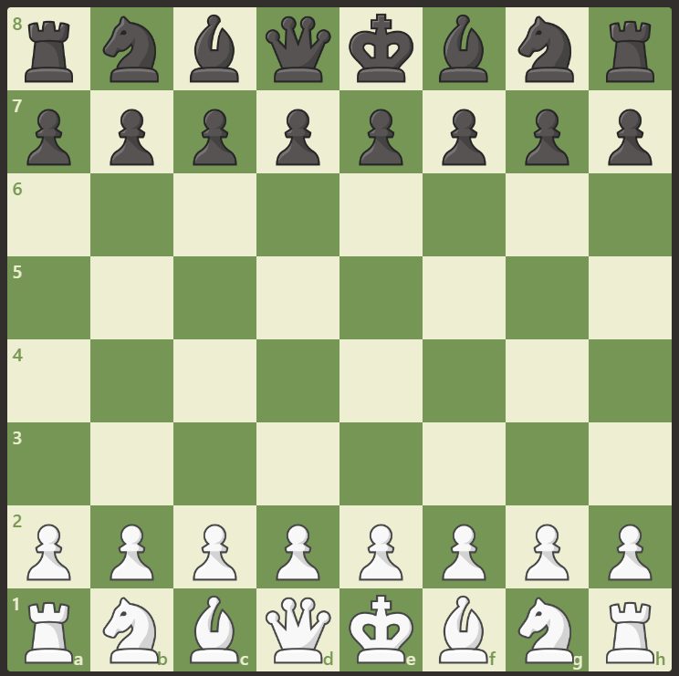
The user select one of their pieces:
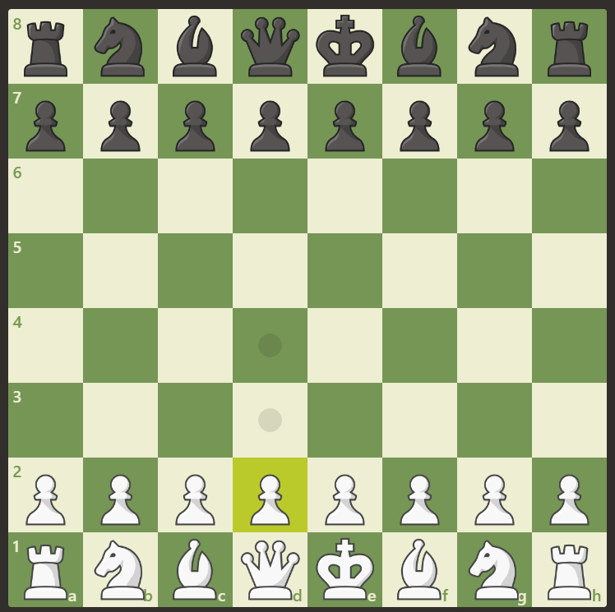
The use then selects the square for it to move to
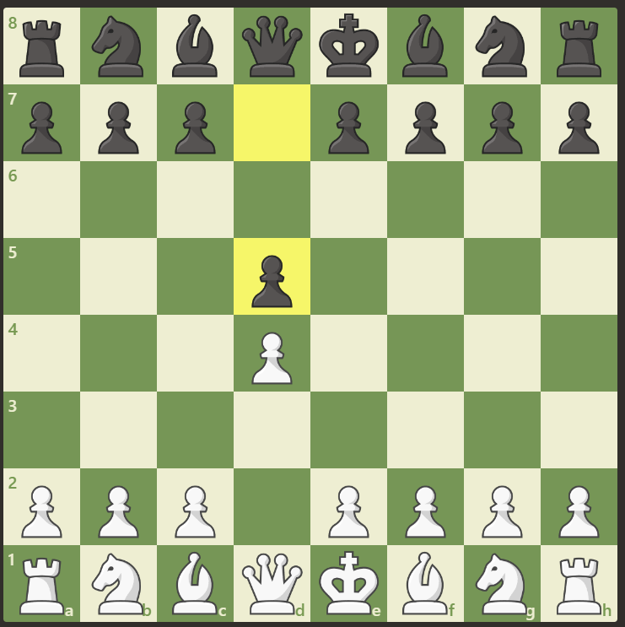
(computers move also shown but this is to be ignored for this explanation)

Outputs:
The first important output is the computers moves in the game. This is to be shown to the user visually using the convention of lichess.org and chess.com by moving one of the computer’s pieces and highlighting the squares it have moved from and into. The move will also be added to a list of the moves in the game. This will be a displayed on the side and an example of how a move could be recorded could be “black bishop moves from F6 to G7”.
The other main output is who has won the game. It must be outputted once the game has finished. I will display that the game is over and who has won. It must also disable the chess board widget to prevent the user making any more moves. This information may be displayed with a popup window but it may be simpler to have a banner appear above the chess board that states who has won.

Preconditions:
The main precondition is that all inputs must be valid. If this isn’t the case then the chess engine will not be able to function.
In order to solve this problem I will try to make many of the inputs forms on any menus feature limited options to reduce the chance of giving an invalid input. For example the user of radio buttons an checkboxes to ensure the only inputs that can be given are valid.
I also need to ensure that the users move is valid. In keeping with the conventions laid out by chess.com and lichess.org I will not display an error message if the user gives an invalid input. Instead nothing will happened and the program will continue to await the users move. This is detailed above in the inputs section. An example of an invalid input that may not be allows (and so ignored) is the user selecting an empty square or one with an opponent’s piece in when selecting one of there pieces to move. Another may be the user selecting an invalid square for one of their pieces to move to (the selected square is not one of the possible legal moves).

Thinking abstractly:
Irrelevant details and properties of the chess board and chess pieces and abstracted and removed to reduce the complexity of the problem. The only details that will be kept will be those that are relevant to the object in game. I will use an objects to represent the abstracted chess board and pieces servers side. To clarify these details we be abstracted ‘under the hood’ in the server side chess engine and the client side validation. The user will still be able to see the colour and general shape of the pieces and the colours of the squares on the chess board when on the website

A chess piece will have these attributes abstracted:
- it’s specific shade and colour. Instead it will be assigned an owner to ensure the user’s and computer’s pieces are distinguished
- The exact physical dimensions of each piece e.g. height and width
- The exact physical shape / profile of the piece
Attributes that will be kept include:
- Which player owns the piece
- The set of possible ways in which the piece can be moves
- The relative value of each piece (to be used by the chess engine)
- Where is it on the board (which square) or is it off the board
- Is the piece a king? Due to handling check the king will be a special case with special properties
The ways in which a piece can move will be represented by a set of vectors.

The chess board will have these details abstracted:
- The colour of each square: it makes no difference in game if a square is black or white
- The physical dimensions of the board e.g. the width and height
The board will be represented server side as an 8*8 coordinate grid. Pieces that are knocked out may be stored in a separate list. Where the pieces are on the board is a detail that must also be stored

Thinking procedurally / decomposition
I aim to break this problem down into subproblems that are more manageable and can be solved independently. The 2 main modules will be the chess engine and the front end website
The chess engine will be responsible for determining a good move to make given the current board state. I intend to implement it by analysing decision trees using the minimax algorithm and symbolic ai. I will go into more detail about this in the design section. An example of how the chess engine may be broken down into sub function is shown
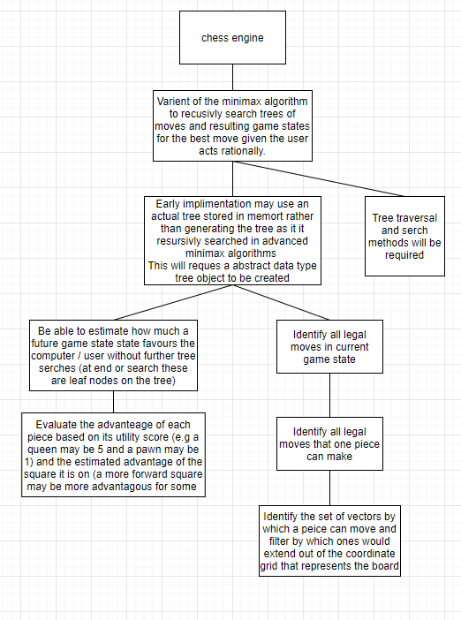

The chess engine will be written in python. The frontend website user interface will be created using HTML, CSS, JavaScript and Flask to act as a python webserver. The function of the website is to provide an interface to the user and validation of the user’s inputs. The frontend and backend will be connected vie with a type of API. This could be a REST API that users HTTP or a type of web sockets as appropriate. HTTP based connection as simpler but sockets allows for a full-duplex low latency connection which is advantageous.

The website will be broken down into pages each of which will serve a function. For example a home page, a user login page and a puzzle game page. Each page will be composed of multiple interactive and static widgets. Each of these will be made up of may HTML tags.
Thinking concurrently (BLANK FOR NOW)
Stake Holders:
Stake holders are those who will be affected by the quality of chess program that is produced
The only stake holder for this game is the end user as its function is purely to provide entertainment. If the chess program doesn’t meet the end user’s needs or is not created then they will be affected as they will not have the opportunity to get the same level of enjoyment from playing with my chess program.
My target audience is a casual chess player who plays primarily for entertainment with the goal of improving at chess being secondary. For this reason the target user is someone who is already a casual chess player or is interested in giving chess a try. They should enjoy problem solving and be of age 8+ as chess is a highly complex game that involves high level strategy and problem solving that many younger children are unlikely to enjoy.

I have identified my parents as specific stake holders. My dad is a casual chess player who regularly plays chess against the computer on his phone at the start of the morning for entertainment. He is familiar with the rules of chess and has the technical knowledge to provide specific and useful feedback about which features he may require. My mum is interested in starting to play chess and doesn’t have a technical background. This allow her to represent the majority of my users and give feedback that is more focused on usability of the interface and features she would want. This makes my parents ideal to help with beta testing of prototypes. It is important to note that unlike other games there are likely to be many older adults (60+) who want to play chess. This demographic may not play other games like shooters but may enjoy games like chess, solitaire, backgammon for example.

As mentioned earlier I aim to ensure my chess program specifically caters to my stake holders (in this case my target audience) in the features that it offers.

I am aiming my program at casual chess players. I have tried to plan the features that I will use accordingly as shown. Further details about each feature will follow in later sections
Because my stake holder is a casual chess player (entertainment first / improvement in ability second) I have decided to implement these features:
- The chess games against the AI will be more casual and will allow you to backtrack and see the board state before the most recent moves to see what is done (a feature on chess.com and one my dad recommended as one he wishes for). A tick box could also be selected before hand to allow for moves to be reversed. This would obviously be an advantage but could be a feature that very new players who are learning may demand
- Puzzles will be made available that aim to be a challenge that can exercise problem solving skills. This challenge will be in the form of a board state that is 1 or 2 moves away from checkmate (the user winning) there goal is to find the path to winning. This should be entertaining and hopefully I will be able to create a variety of different challenges of different difficulty
- As the games are casual there will be no clock that limits how long the user has to play. This is standard in tournaments but I am trying to emulate casual chess that is played on a kitchen table between friends so these features server no purpose.
- The most important one as mentioned in interview: The user will be able to dictate the starting conditions of a match in order to have a fun off the wall match. For example where they have an unfair advantage over the hardest AI by starting with 1 king and 8 pawns as normal but all other 7 pieces are queens. This should be a fun and different game for the user to play.
- Casual chess players are less likely to be completely committed to chess in comparison to competitive players. This means that they may appreciate other games being made available that are similar. For example draughts. These games are similar to chess in terms of the board and pieces but may be a refreshing change for users.
My older stakeholders (e.g. 60+) may be less familiar with mobile devices and technology
In order to ensure my chess program is suitable for people of all ages I will ensure that the final product is distributed as a website and as a mobile app if possible. I believe that older people are less likely to own a smart phone or be familiar with touch screens. I know that my own grandfather plays solitaire on his PC computer on a website as he is more comfortable with this. This way older users should still be able to make use of the website. I aim to prioritise usability over aesthetics in the user interface design. I will also aim to ask my mum for feedback in detail about how the user interface can be improves to ensure the program is assessable to everyone.
Research:
For my research I have:
- Looked into 2 online chess games to see their features and functionality: chess.com and lichess.org
- Interviewed my dad who is a casual chess player who plays chess daily on a mobile app
The first existing solution I researched was https://www.chess.com/
It is a more broad chess website that features a variety of chess content
I will specifically focus on the playing chess against a computer features of the website.
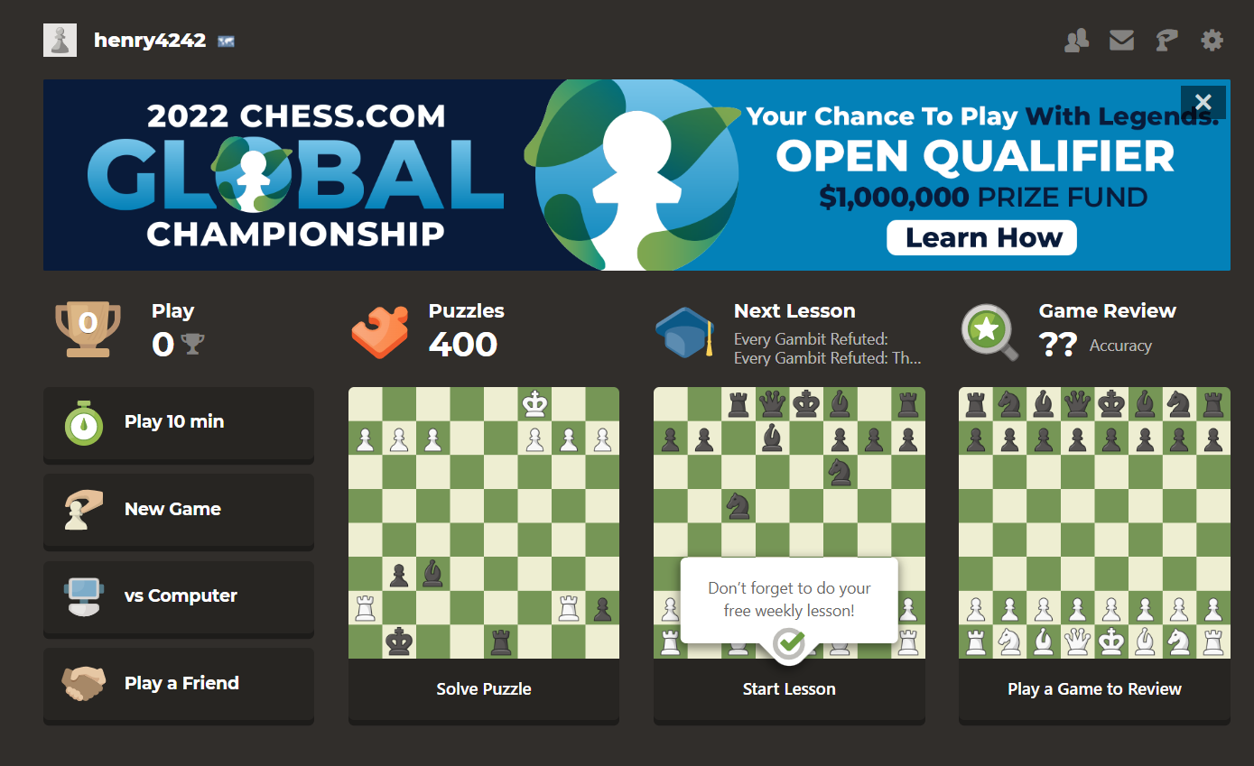

The user interface shows of the many features including the opportunity to play puzzles, collect trophies, review my gameplay or play another user. This site was clearly developed by a large team with lots of resources. While there are many sites where you can play chess this site seems to have a massive scope which make sense considering its 77 million users.

This site also allow for logging in which allow for users to access other features and upgrade to the premium mode. The login process was smooth as I could login with google preventing the need for an verification email.

Once I began to play a game I was asked to select a few pre-game configurations
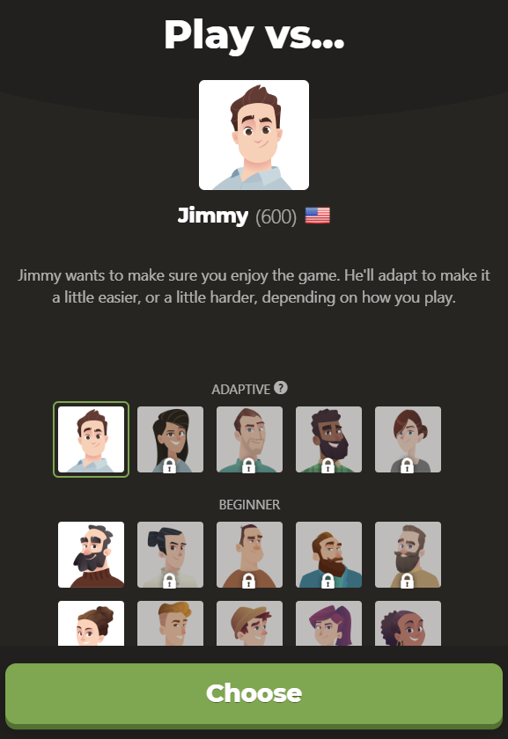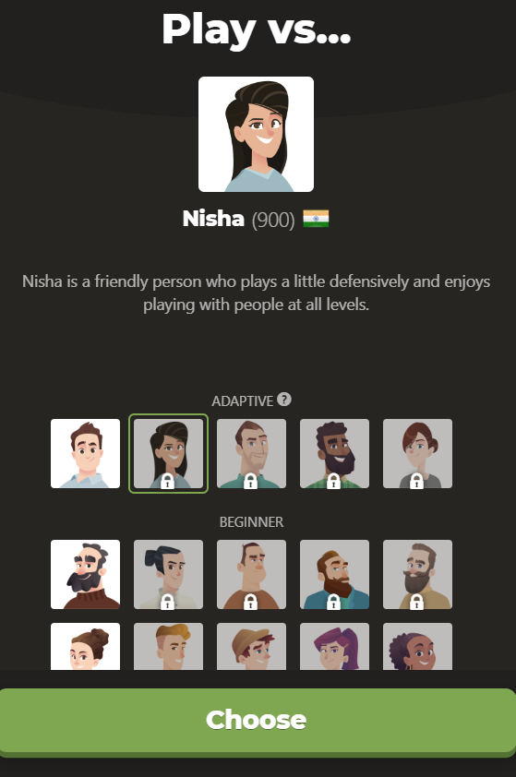
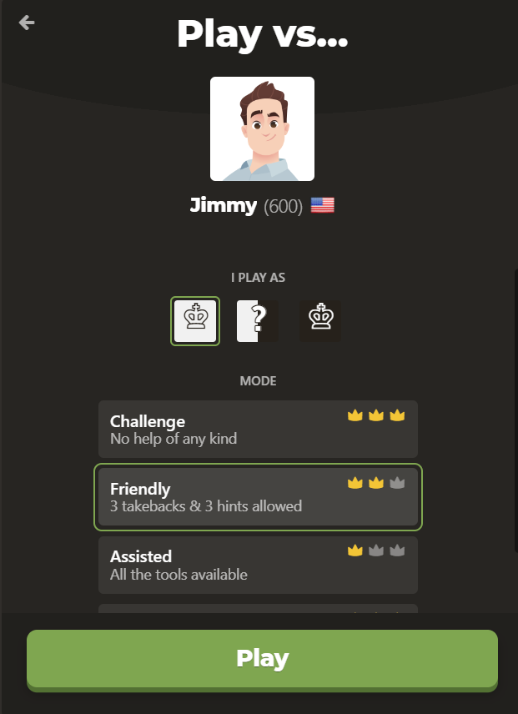

Interestingly they offered more than just different difficulty settings. They seemed to have different chess engine configurations represented by personas like Jimmy and Nisha with different skill levels. This seemed to dictate difficulty and the play style of the AI opponent.
The user then had the option to select how much help they wanted in the from of hints and takebacks.

Then the game begins and an interactive widget is used to represent the board visually to the user.
The user can then select a piece to move and the square to move it to. Then the computer will make its move. Selecting an invalid square or piece does nothing and the program still waits for you to make a valid move. One you do your computer opponent immediately makes their move. The move they made is highlighted by yellow squares to make it clear to the user what the computer has done.
For the users benefit there is a list of the moves made by each player
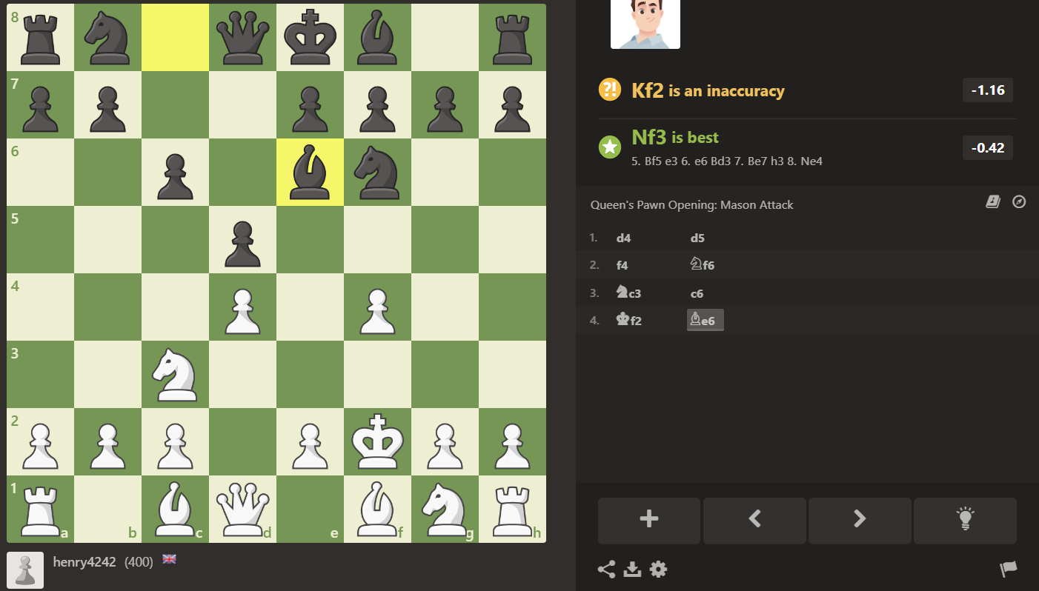
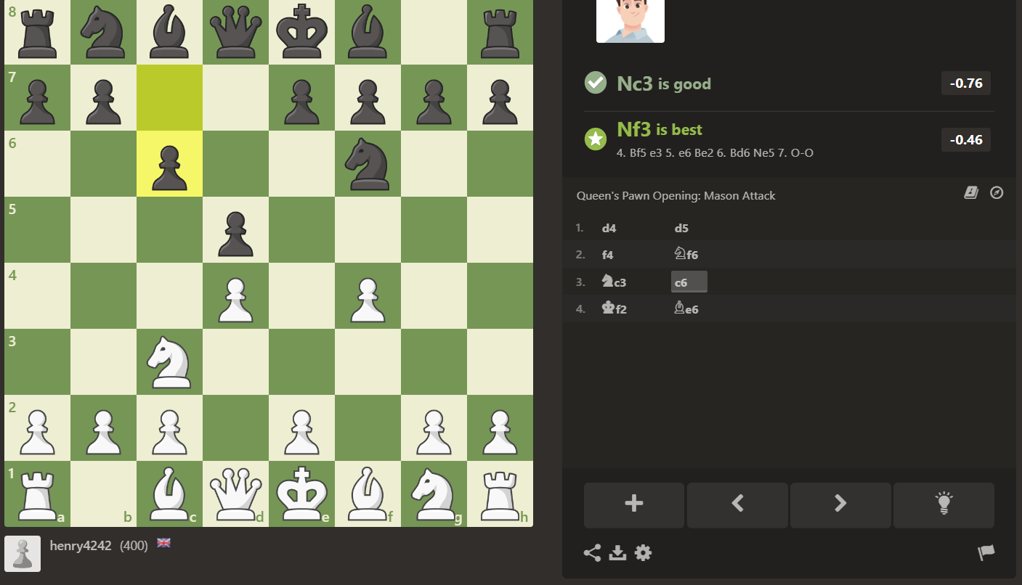
This list is interactive and clicking on a move will revert the board to the game state immediately after that move. This is shown above.
I ultimately find this list confusing and not descriptive without using the step back feature. Some moves have an icon next the square they moved into to show which piece moved but there is no icon for pawns. Additionally without stepping back through you cannot tell which square the piece came from originally.
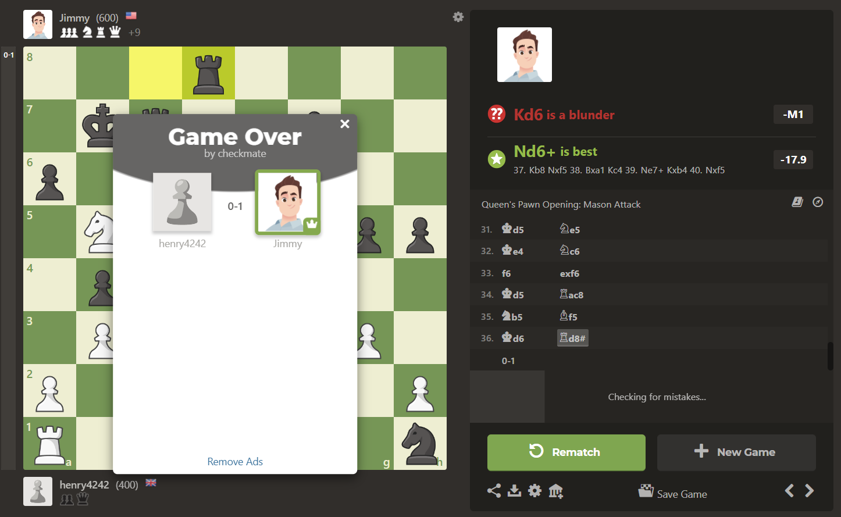
Once checkmate is reached the game ends as the chess board prevents new moves from being made. A popup window show that the game is over and who won. The rematch button is highlighted to attract the user’s eye. Taken pieces are shown next to the player along with name, picture and trophies.

Overall chess.com is a highly functional website with incredible scope and many other features including allowing 2 users to play chess against each other over the internet. I thought that for the most part the user interfaces were clear however sometimes there was information overload due to the amount of options and statistics on each page.
I likes how the difficulty setting and the help offered in game settings were distinct and different. I am likely to use this in my program.
I thought that some of the features may have been more suited to more competitive players. For example trophies and match feedback e.g. “Kd6 is a blunder”. In addition some functionality such as some of the puzzles and ai opponent personas were locked until you had played more on there website. I will not lock and features from logged in users based on trophies etc as such a feature seems wouldn’t meet the needs of my casual chess player stake holders who may not have time to play regularly.

I then conducted an interview with my dad:
He is a casual chess player who plays chess on a mobile app on his phone most days. The app he uses is called lichess and is available both as a mobile app and as a website (https://lichess.org/).
He mostly uses lichess to play games vs the ai (it like chess.com has many options of how to play)
I asked him about what he liked about lichess:
- He liked the fact that he could choose a difficulty level. This makes sense as it will allow different players of different abilities to still play at the challenge level they want. It also allow one person to have an easier or harder game if they want
- He liked the interface as it was user friendly. He particularly likes how you can drag and drop or click to move pieces rather than type in what move you want to make. He found this easier to use and more intuitive
- He especially mentioned the satisfying sounds that this site uses as being an attractive feature, there is one sound for moving a piece and one for taking it
- He also likes how the moves are recoded and he can see the last move visually with highlighting and see a list of moves made in the game. It is also possible to step back through the moves like chess.com
I had a look myself at lichess afterwards and noted how it’s interface seemed to be very similar in its features and design to chess.com suggesting that a convention is followed
Lichess also allows for 2 users to play against each other online but I am more interested in the chess vs a computer component
The same interface for getting the move input and stepping back through the games is used
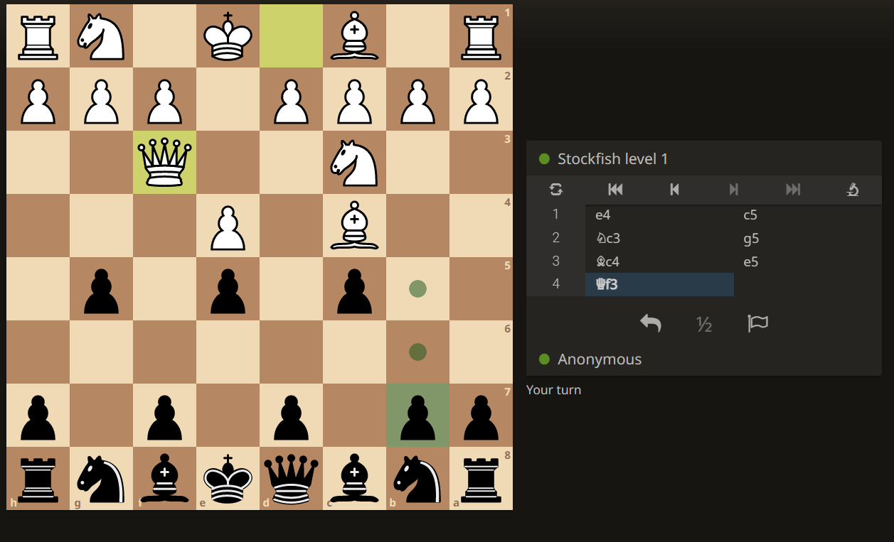

One of the feature he likes about li chess is how configurable a game is. This is perfect for a casual player as it allows for colours to be changed (for example to brown and cream) and the colour that the user plays as (white which goes first, or black). In addition the starting positions of the pieces can be configured. This has allowed him to play variations of chess against the strongest AI where he plays with an unfair advantage. For example him having extra pawns of the opponent having no queen.
The second feature he likes that chess.com doesn’t have and I am now considering adding is an undo button that allows the last move to be taken back. He is a casual player and uses is occasionally when he miss clicks and selects the wrong move. He pointed out that players know that it is a kind of cheat and can always chose not to use it.
The third feature he likes was the puzzles. Some of these puzzles are about finding the path to checkmate in 2 moves and others are about maximising your utility score over the computer by seeing the advantageous move. For example one of the challenges was to see how you could make 2 moves to sacrifice a knight in order to take a queen. He wasn’t told that this is what he was aiming to do. If he selected the wrong move then he was asked to try again and given the option to see the solution. Then the computer made it’s counter move and he was asked for a move for the second time. He said he enjoys this as even though he doesn’t take chess to seriously he still sometimes wants to improve. He also plays a puzzle when he doesn’t have time for a full game.

We then discussed some other features and he gave me his opinions.
He said that it would be really useful if the server would store the game as it is currently after each of the users moves. This way if the website was closed or Wi-Fi is lost then the game can be continues when the user logs back in to the website. He said that this wasn’t a feature that he was aware of on lichess.
He said that he wouldn’t be interested in a trophy reward system for winning matches or a leader board for ranking players this way.
He also said that he thought that if I add in a move clock / timer is should be optional. He said that while some players may enjoy the tension it creates, he enjoys having the time to fully consider each move. He viewed this as more of a feature for competitive players (who are not the target audience).

He also said it is important that difficulty settings are discrete not continuous (e.g. not a slider) so users can ensure they are playing on the same difficult.

Essential Features:
One of the desirable properties of this project was how simple the most basic chess program could be. For this reason the essential features are relatively basic. The goal is to then add in features form the success criteria on top of this.
How I aim to implement this is described in decomposition section
The essential features are:
- The user interface must have a menu where the user can select the difficult of the game that they would like to play.
- It must then present them with a fully functional chess board widget as is discussed at length in the research and thinking ahead section to allow the user to enter moves and see the computers move
- Proper validation must be in place in client order to ensure that the new game state resulting from the user’s move is only sent to the backend chess engine once a valid move is inputted
- The client side JavaScript must be able to recognise when the game is won, stopping the game and announcing the winner accordingly.
- The server must be able to keep track of the current board state by representing the chess board with an instance of a dedicated class or with a data structure such as a 2 dimensional array
- The server must be able to determine a good move given the current board state. The goal it to use the minimax algorithm in later versions. At its most basic looking one move ahead and picking the one that gives the greatest utility score advantage over the user will suffice (so a move that takes a piece for example)
- The chess engine must be able to pick moves that give it a overall utility score advantage over an opponent in the early and mid-game
- In the late game the chess engine must aim to get to checkmate over taking other pieces to ensure that it is able to actually win the game

Limitations:
Here are some of the possible limitation of my current approach and how I aim to overcome them.
Firstly, if I am not careful, the graphical user interface may not be intuitive to older users. As mentioned some of the stake holders will be older (60+) and it is important to try to make the solution as accessible to them as possible. Older users may be less confident using a touch screen as an input device and may not have access to a smart phone. For this reason I think it is important that the website can also be accesses through traditional laptops and PCs. Older users may find it easier to use a mouse and or keyboard. However it is clear that this solution will not be suitable for some older people who enjoy chess if they lack basic computer skills (which I not uncommon).

Secondly, it would be difficult to add in specialist moves like castling and en passant. This is because these moves are special cases and so are more than just a possible vector that a piece can move. As such they will be difficult to implement if I do indeed decide to use a vector space and set of vectors to determine the legal moves of a piece. Perhaps later versions of my program could include specialised code to add these moves as a feature but this will not be present in earlier versions. While this means that the program will fail to meet the needs of competitive players who need these moves in their repertoire, I hope that this will be less of an issue for the casual players at which this chess program is aimed.

The third potential limitation of the full stack website approach is to do with the use of server side code that includes my chess engine. The work load of my server program will be proportional to the number of users as they will all use my server side chess engine. As a result costs will be proportional to the number or users and will not be recouped as there is no current plan to monetise the application. Hopefully this will not be an issue as the it is unlikely that the program will have may users but in a real life issue this would be an issue. In addition having a web application as opposed to a downloadable executable file creates complexity in the form of webhosting. For example I may need to host with a cloud provider like AWS. This would mean paying for computation and storage space used by the database. It would also mean that I would need to purchase a domain name for the site. I would need to ensure my server was secure against attack (for example sql injection or stealing users data). I may also require specialist API services such as an email api to allow me to verify the emails of new users that sign up.

The forth issue is that I will have to ensure that I comply with all relevant laws and regulation if I decide to allow users to login. This could be complex to check I am following as I don’t have access to a legal expert. For an example, I would need to ensure the minimal amount of personal data I store on each user is in compliance with the data protection act. For example this means I would need their permission. One possible solution to both this problem and the email API problem is to use a login with google feature. This would allow google to handle obtaining the users details in advance and asking for their consent for this site to use them. However this would be highly complex to implement.

Solution Requirements:
In order to implement my solution I will need to rely on a variety of libraries, pieces of specialised software and online services.
I will require online resources:
- A domain name
- Online web hosting and compute to run my full stack python application and the chess engine
- An online storage solution for the database as appropriate
- API keys relevant to allow me to log users in. For example I may need to register a new project on my Google developer dashboard and fill in relevant forms the enable users to login with google giving me access to basic information like name and email (and importantly a mechanism for logging users in). Alternatively I could implement the this myself with an emailing service and corresponding API
I will require specialised software:
I will need to host my python full stack flask application. For this I will need a WSGI standard webserver such as waitress and a virtual machine running ubuntu in order to run this python program.

I will require programming and scripting libraries, languages and corresponding compilers / interpreters:
- JavaScript libraries: for example I am likely to use VUE.js for its superior component system and server side rendering
- I will use typescript, the JavaScript superset that is type sensitive. This will make programming and debugging client code easier but will require the appropriate compiler to convert the typescript to JavaScript
- I will require SQL database software like MySQL server in order to securely store user data if I decide to allow users to log in.
- I will require the python interpreter and pip package manager in order to install dependencies and libraries that I
- will use.

Success Criteria:

Feature name | Importance | Description | Justification
Difficulty settings | essential | The user is able to select from at least 2 different difficulty settings before the game | Interview
Validation client side | Essential | Due to the precondition the program must continue to await the users move if they select a square that doesn’t contain one of their pieces | is needed for chess program to function at all
Validation client side | Essential | When the user clicks a square for their piece to move into it must be a legal move for this piece to make | is needed for chess program to function at all
Validation client side | Essential | When in check the user must not be able to make a move that results in them still being in check | is needed for chess program to function at all
Intuitive Move Input with dot markings | High priority | Once the user selects a piece to move, dots should indicate the legal moves that piece can make. Once a marked square is clicked the piece should move into it | Interview and research
Computer Move output | Essential | Following each move by the user the computer must make a move shown by their piece moving | is needed for chess program to function at all
Highlighting | High priority | After the computer makes a move the squares that this piece moved form and to should be highlighted | Research of chess programs
Chess engine mid game | Essential | To at least some extend the chess engine should be able to select moves in the mid and early game that take the opponents pieces and provide a utility advantage. | is needed for chess program to function at all
Chess engine late game | Essential | In the late game, when given the opportunity, the chess engine must at least aim to take the king in order to ensure it can close out the game | is needed for chess program to function at all
Undo button for last user move | Ideal / desirable | The user should be able to undo their last move and make a different one, then continue playing the game | interview
Log of history of moves in game | Ideal / desirable | When a move is made it should be added to a list of the moves in the game for later reference by the user: e.g. “white bishop from F4 to G5” | Interview and research of online chess programs
Step back through log | Low priority | The ability to see the board state before a certain move was made in order to see what has happened in the last few turns | Interview and research of online chess programs
Fast and reliable connection between front and backend | Essential | The API interface between the frontend and backend must be robust and it must be efficient in order to not compromise the websites performance or cause functionality to fail | Essential in order for a web interface to work
Allowing users to login & sign up | Low priority | Allow users to create an account to allow access to other features | Research into other chess sites
Reloading unfinished game | Low priority | Allow a logged in user to continue a game from where they left of it they login again | interview
Puzzles | Ideal / desirable | Allow users to engage in puzzles to try to see the best moves in some preloaded game state | interview
Draughts | Last add, very low priority | Allow users to play draughts vs the computer | N/A low importance
Allow users to start with a custom game layout | Ideal / Desirable | For example users could start a game with a second queen or deprive the ai opponent of a queen | interview
Recognition and appropriate output on winning | Essential | It must be recognised when the game is won and, the game must end (no more moves), it must be outputted who has won the game | is needed for chess program to function at all
Leader board and trophy system | After interview I no longer want to implement this | Logged in users can earn trophies by winning games and completing challenges. Players are on a public leader board by trophies
Accessibility through website | Essential | This will make the end product more user friendly to older users | Thinking about stakeholders needs
Mobile access | Desirable | I could make the website work on the aspect ratio of a phone. This makes the program more accessible for those on the go | Thinking about stakeholders needs

